SUBSTITUTION
Pearson Edexcel - Thursday 2 November 2017 - Paper 1 (Non-Calculator) Higher Tier
1.
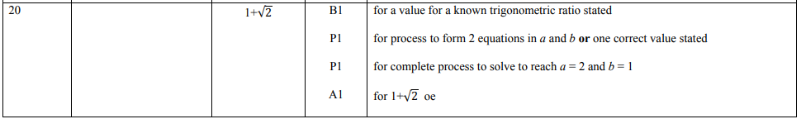
Pearson Edexcel - Wednesday 8 November 2017 - Paper 3 (Calculator) Higher Tier
2.
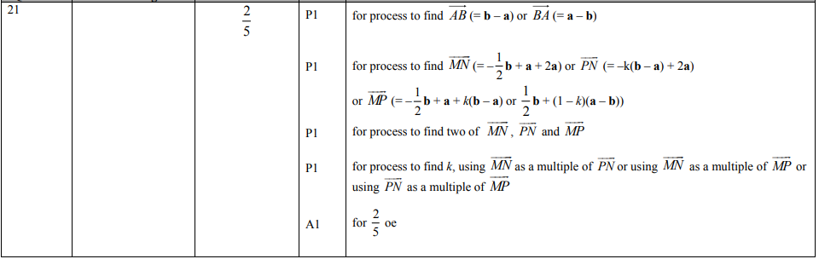
Pearson Edexcel - Wednesday 13 June 2012 - Paper 2 (Calculator) Higher Tier
3.
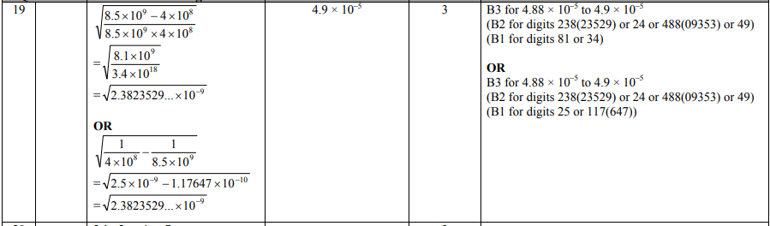
Pearson Edexcel - Tuesday 10 November 2009 - Paper 4 (Calculator) Higher Tier
4.
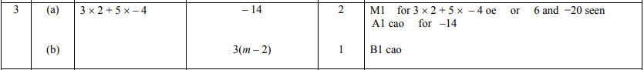

OCR GSCE – Tuesday 5 November 2019 – Paper 6 (Calculator) Higher Tier
5.
OCR GSCE – Tuesday 11 June 2019 – Paper 6 (Calculator) Higher Tier
6.
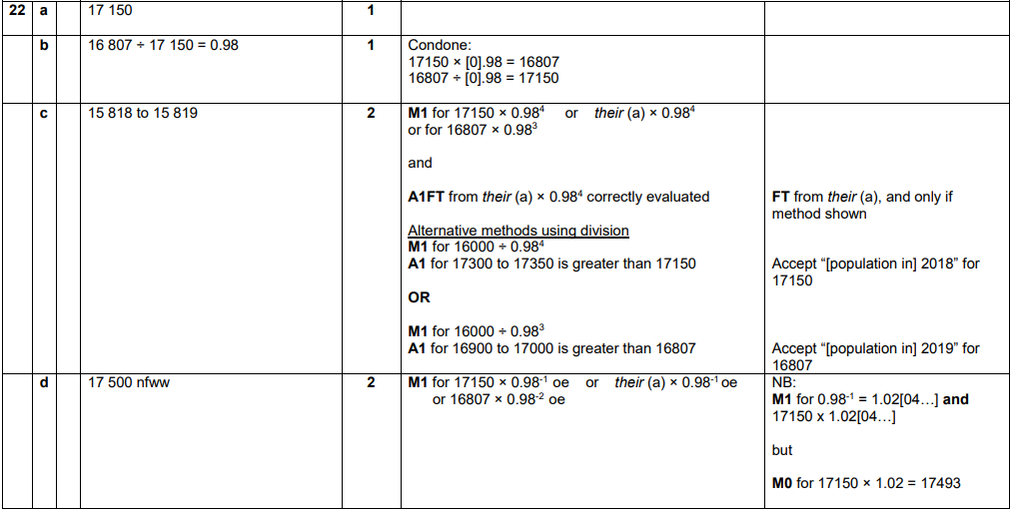
OCR GSCE – Thursday 24 May 2018 – Paper 4 (Calculator) Higher Tier
7.
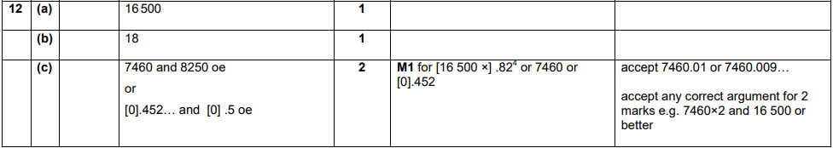

OCR GSCE – Thursday 7 June 2018 – Paper 5 (Non - Calculator) Higher Tier
8.
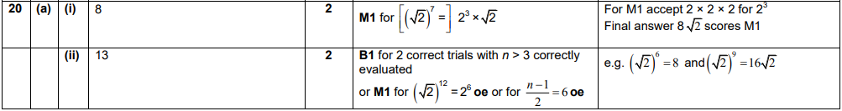
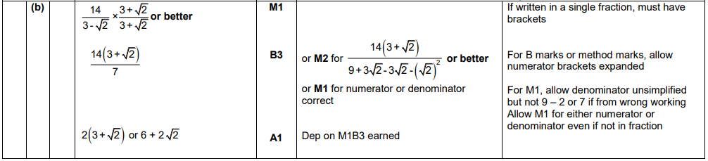
OCR GSCE – Tuesday 6 November 2017 – Paper 5 (Non - Calculator) Higher Tier
9.
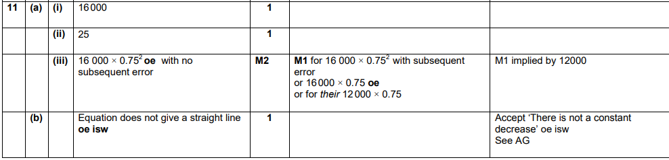
OCR GSCE – Wednesday 8 November 2017 – Paper 6 (Calculator) Higher Tier
10.
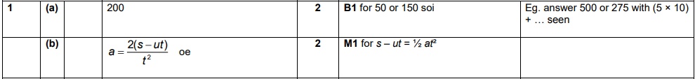

OCR GSCE – Wednesday 8 November 2017 – Paper 6 (Calculator) Higher Tier
11.
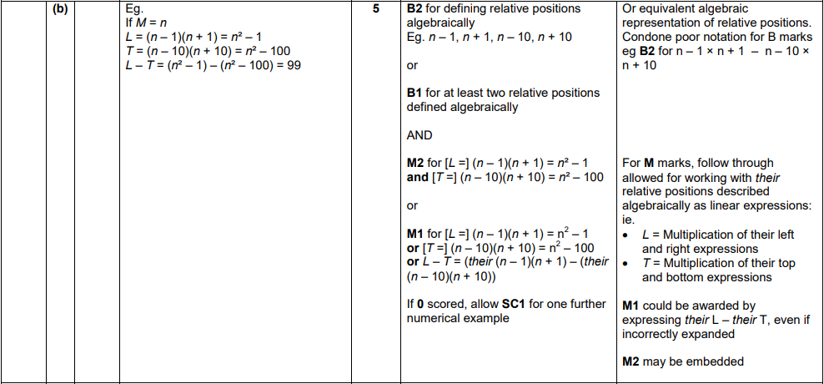
OCR GSCE – Thursday 25 May 2017 – Paper 4 (Calculator) Higher Tier
12.
OCR GSCE – Thursday 25 May 2017 – Paper 4 (Calculator) Higher Tier
13.
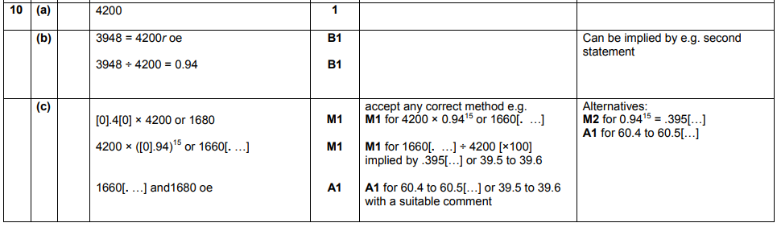

OCR GSCE – Sample Papers – Paper 4 (Calculator) Higher Tier
14.
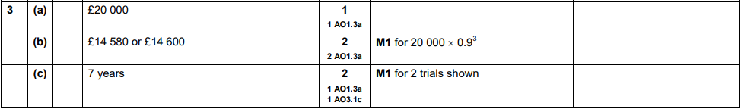
OCR GSCE – Sample Papers – Paper 6 (Calculator) Higher Tier
15.
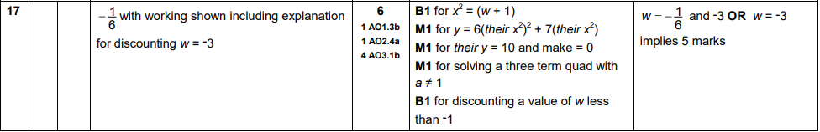
AQA GSCE – Tuesday 21 May 2019 – Paper 1 (Non - Calculator) Higher Tier
16.
AQA GSCE – Thursday 6 June 2019 – Paper 2 (Calculator) Higher Tier
17.
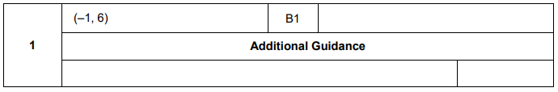
AQA GSCE – Thursday 6 June 2019 – Paper 2 (Calculator) Higher Tier
18.
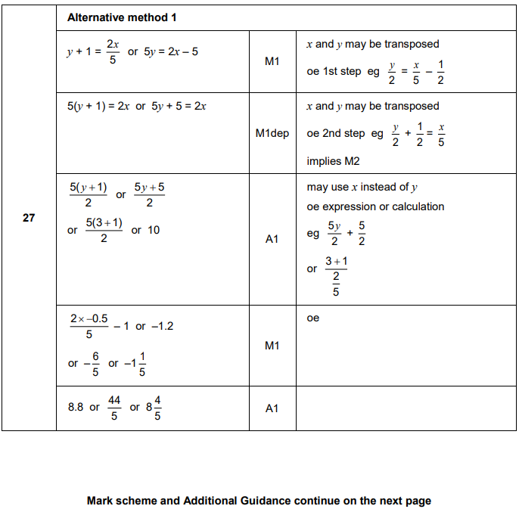

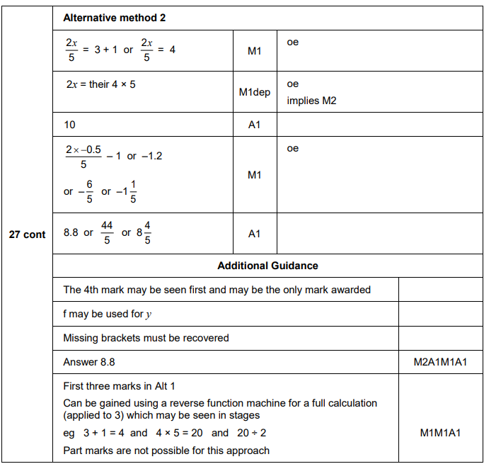

AQA GSCE – Tuesday 11 June 2019 – Paper 3 (Calculator) Higher Tier
19.
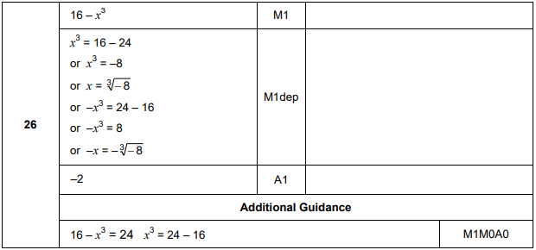
AQA GSCE – Thursday 8 November 2018 – Paper 2 (Calculator) Higher Tier
20.
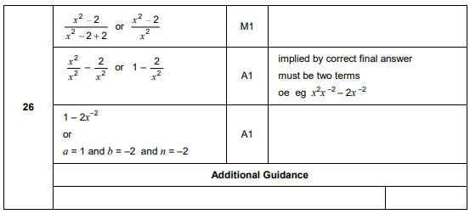
AQA GSCE – Thursday 8 November 2018 – Paper 2 (Calculator) Higher Tier
21.
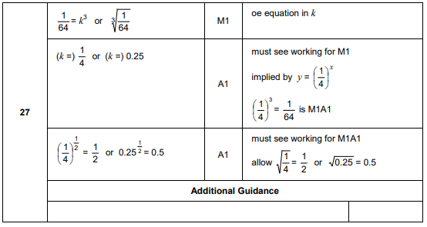
AQA GSCE – Thursday 6 November 2017 – Paper 2 (Calculator) Higher Tier
22.
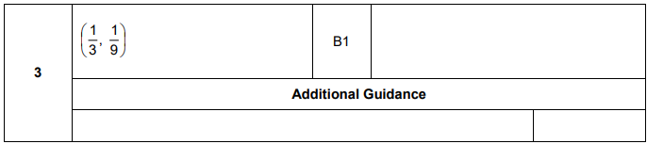
AQA GSCE – Wednesday 8 November 2017 – Paper 3 (Calculator) Higher Tier
23.
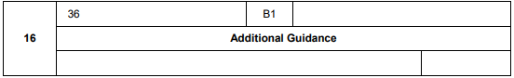
AQA GSCE – Wednesday 8 November 2017 – Paper 3 (Calculator) Higher Tier
24.
